FocusLine

Lakshimi Pushyami Yetukuri

Walton High School

1590 Bill Murdock Rd, Marietta, GA 30062

1/19/17

Table of Contents

Abstract 3

Introduction 4

Background Research 5

References 7

# Abstract

FocusLine product was created to help people with disorders such as ADHD, and help them focus in their work. Distractions are everywhere and many people are affected by them. Students aren’t able to focus in their work or pay attention in classes for many different reasons. Our goal was to create a product that students would most likely use every day. To help these them, our team has decided to make a product which has a timed buzzer inside a pen that buzzes when it is not in use. The movement of the tip of the pen breaks or completes the circuit. The circuit is broken when the pen is in use. It is a complete circuit when the pen is not in use and after two to three minutes the buzzer will go off. If the user doesn’t need this feature of the pen, they can just cap it. This puts the pen in the same state where it is being used due to the rubber stop inside the cap that pushes the tip back when it is tightly capped. We didn’t create a prototype yet because our final design just looks like a normal pen. The final step is to just make the circuit working so it can be inserted into a pen. This is a product that would help increase a person’s productivity and help save time.

# Introduction

Have you ever been distracted by a text tone and completely forgot about your work, or day dreamed in the middle of an important lecture? If yes, then you are not the only one. Many students, even adults, are easily distracted from their work whether it be because of the boring work, distracting friends, messages on social media or just staring off into space. For students at school, this results in not listening during lectures which would affect their grades. On an average a student doesn’t pay attention for 10-20 minutes continuously during a lecture (Weimer, 2014).

At home, many students start to do their work but are easily distracted by the sounds made by their phones. They are so curious about what it was about that and leave the work at hand and go to check, finally forget. There’s not anything wrong with checking your phone because there might be an emergency. Some don’t just quickly check their phones; they somehow end up spending hours on it. “Just having your phone near you can distract you and negatively affect your work performance” (Torres, 2015).

This not just a problem with phones this also happens when watching TV or playing video games. This affects the students learning ability and their productivity. For many adults, this not as big of a problem as it is for the students. This is because they have few days or weeks to complete their tasks to submit to their head employer, but this is also a bad thing due to procrastination. Sometimes work is put off to the last minute and sloppy work is turned in. A constant reminder is needed to help them get back to work.

Our teams goal was to create a tool that would be a constant reminder when the user is distracted. We agreed on few ideas that were making the product better and enhanced, accepted to implement in our final design. One of the idea we agreed on was that our invention should be inserted in a daily used school supply, so it would be easier to carry around and is not easily forgotten. The second idea was, product shouldn’t be loud or noisy, and only something that the user would know when the product was at use.

After much debate, we decided our school supply was going to be a pen because it is something both adults and students use. Instead of making a device that could be added to a school supply, our team decided to permanently insert the device into the pen that would buzz as the reminder. It was going to be a timed buzzer so we needed a design or an already existing product that would act as the timer. The issue was we didn’t know how to make our design fit in a normal sized pen with a buzzer and a timer.

# Background Research

The problem was to create a design that would help people with attention disorders or be a reminder to people to get back to work. The reason for this product was because people are distracted many times throughout the day. This hinders them from getting their work done and reduces their level of productivity. This is a serious problem with teenagers and their obsession with their phones; they spend nearly 10 hours on social media (Tsukayama, 2015).

We studied many products in the market and their features and the technology used. From which we took the following products or inventions as the inspiration for baselining our product and improve on:

* #CN205255823U (Jianfeng, "Natural vibration sign pen ", 2016) -- This patented product is very similar to ours with two most important anticipated features in our product. One, the same design. Second, functionality. But we both are trying to solve different problems. While the patented product was trying to prevent Myopia, which is near sightedness, by placing a buzzer inside the pen to tell the user of the pen to take a break after a certain time period, where as we are trying to help the user focus on their work. While that patent has a similar function to ours, our design would want to have a vibration element position near the end of the pen.
* #*US6672168* (Higgins, "Multi-level machine vibration tester marker pen", 2004). This pen works using a simple button connected to a vibrator to work.
* (Hechtle, "Ball-point pen mechanism", 1966) -- The inkwell wants to naturally eject from the pen due to a spring with a button at the back of the pen.

In our design, we used design similar to (Hechtle, "Ball-point pen mechanism", 1966), so it pushes out while simultaneously pushing a button in the back of the pen causing a circuit to be connected, which in turn sets of a vibrator (similar to #*US6672168)* after a minute or so. The circuit is broken when the person begins writing because the force of the pen to the paper is enough to release the button. In order to stop the pen from buzzing while it is not in use, a cap with a rubber stopper is included.

The target market for our product is people who just have trouble paying attention in general, mainly because the students surveyed all have trouble paying attention, and 68% of workers have trouble paying attention at work ("Survey Finds 68% of Workers Distracted by Internet on the Job", 2015). Those people can have attention deficit disorders or just have trouble staying on task. A main user/buyer would mainly be parents and people with ADHD and similar types of disorders because as of 2011, the CDC and APA estimate that 5-11% of US children have ADHD ("Data & Statistics", 2016). Another user/buyer would be just people who recognize that they have trouble concentrating.

The user interviews did not reveal that the customers did not have any specific requirements for the product. The engineering requirements in order to design and manufacture this product is a shell that would not crack or break while under rapid movement. This can be achieved by using thermoset plastic (Industrial Strength Marketing, William Golden, Brenth Lathrop 2011, "Thermoset Vs. Thermoplastics"). We also need a timer circuit system in order to set off the vibrating element after about a minute (Jayant, "1 Minute, 5 Minute, 10 Minute and 15 Minute Timer Circuit Diagram using IC 555"). Whenever a person is inactive due to distractions, the vibration serves as harmless, corrective, negative reinforcement to regain the person’s focus, just as it does for pets ("What Is Static Correction?").

The pen is very useful in the sense that it serves its function when people most need it. Not only are they going to be using a tool required for strenuous work, but the tool also serves as an attention helper. To demonstrate the proof that our system works, we will build a functioning model and ask various people to use the pen for a day at work or a class period at school.

Design and Methodology

The beginning of our project, our group decided to find solution to a problem that would help the students at school. We got the idea of helping the students with attention disorders to stay focused and be in the current in class. This was very important to us because of our personal experiences. A friend of mine suffers from this condition making her set back in school work, affected her life every day and someone has to constantly remind her to get back on task. The solution had to be an object that would remind the user to get back to work. Our group came up with a device that would buzz every few seconds to help the user. The problem with this was that if the user was already focused and working on their task, it would distract them. We also wanted to incorporate this idea into an everyday school material so it would be easier to carry around and the user won’t leave it behind. After lot of brain storming about different devices we concluded that our final solution was to put the device in a pen. This is a perfect idea because it would solve the problem of random buzzing with a set timer automatically triggered when the pen is not in use. This is also a school material that one wouldn't be left behind.

The prototype was manufactured by taking a normal pen and cutting off the end of the inkwell and putting a dowel of wood in its place to represent the vibrating element. There was also a small extrusion of wood glued to the inkwell to push the button. The cap of the pen was altered as well with an extrusion on the inside to push the inkwell up when not in use. The vibrating element is setup in a circuit with a button and a timer to set it off. We have designed and tested several prototypes to make sure that the final design meets all the required design specifications and the outlined functionalities of the device. The major functional features include, the timer to identify the idle time with the ability to set the idle time. If the user uses the pen before the idle time reaches, it should reset and wait for the next idle time to trigger when it meets the specified timer. When the vibration is triggered, user should be able to reset it quickly not to distract or irritate the user.

We build many prototypes along the following guidelines. We have identified all the variables in design and the corresponding dependent factors to make sure that the design works. This gave us opportunity to try out and design different models of the device. These include the spring design to accommodate different user styles of writing and force being used. Second, idle timer, vibration circuits design and incorporating into the design for improvement of the product usage.

The testing for each prototype was to test how the pen held up by being pressed many times to see if the timer resets as it is being used. The springs used should match with the different user styles of writing to create enough impact to set or rest the timer with push of the button arranged. We also capped the pen to see if the well raised enough to shut off the mechanism. The timing circuit was also tested to see if it properly lasted for about a minute before going off. For each model we developed a set of test scenarios and test steps. We have multiple testers carrying the testing at various stages like unit testing, QA testing by a team of qualified testers / users and recorded the test results in an excel sheet with pass / failure information along with the exact nature of failure.

We have followed iterative design approach. First we have most of the mechanical components like sprints, mechanical buttons and electronic chips for idle timer and vibration circuits. As these are bigger in size we wanted to remove mechanical components with electronic sensors to identify the use / nonuse of the pen with set broad range of parameters.

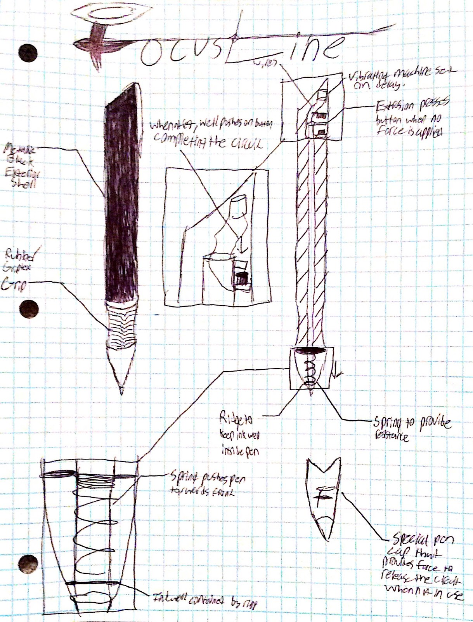

Conclusion

The end goal was to create a device that would help the students with attention disorders, and it was accomplished. There is no product out there with the same purpose as FocusLine. The Asian product was similar to ours in design but it had a different and opposite reason. It was designed to remind students to take a break from work. It isn’t necessarily better than ours but it is very similar to ours. Our first idea was to build a complete circuit inside the pen with wires, switches and a timed vibrator. Then we realized that all these materials wouldn’t fit in the small pen so we had to come up with a different design. The new ideas were to design a timer and vibrating circuits which fits in the design models of ours. Another idea is to use the latest technologies to fit the complete mechanism in the inkwell without any springs to identify the pressure range and automatically sets the idle timer and vibration. This reduces the complexity in design replacing with all electronic chips. The problem currently is the timed vibrators, that were going to reduce the size of the design and help fit in the pen, can’t be found online. This is the problem that we are trying to fix now.

This product can be sold. Hopefully one day FocusLine can be a sold at an office supply store. The pen is not a very expensive product, because the materials that are used to make it are low cost material or electronic chips. We are currently working the enhancements to the current design of the overall product to make it attractive, useful and robust bringing technological advancements. The name of the product is already decided and its FocusLine. The name was chosen because of its purpose to make people focus on their task. The design for the pen is just the look of a normal pen.

Acknowledgements

A very big thank you to Mr. Devaraju Yetukuri for his help in understanding me the importance of multiple prototype design importance and testing procedures. A big thanks my colleagues for making this project sessions more enthusiastic and interesting during discussions and prototype development.

# 

# References

Weimer , M. (2014, January 23). Students and Attention: An Interesting Analysis. Retrieved January 19, 2017, from <http://www.facultyfocus.com/articles/teaching-and-learning/students-attention-interesting-analysis/>

Torres, N. (2015, July 24). Just Hearing Your Phone Buzz Hurts Your Productivity. Retrieved January 19, 2017, from https://hbr.org/2015/07/just-hearing-your-phone-buzz-hurts-your-productivity

Tsukayama, H. (2015, November 3). Teens spend nearly nine hours every day consuming media. Retrieved January 19, 2017, from <https://www.washingtonpost.com/news/the-switch/wp/2015/11/03/teens-spend-nearly-nine-hours-every-day-consuming-media/?utm_term=.b71179becb14>

Jianfeng, H. (2016). *U.S. Patent No. CN205255823U*. Washington, DC: U.S. Patent and Trademark Office.

Higgins, R. A. (2004). *U.S. Patent No. US6672168*. Washington, DC: U.S. Patent and Trademark Office.

Hechtle, E. (1966). *U.S. Patent No. US3288115*. Washington, DC: U.S. Patent and Trademark Office.

Release, P. (2015, January 29). Survey Finds 68% of Workers Distracted by Internet on the Job. Retrieved January 19, 2017, from <https://www.corpmagazine.com/technology/digital/survey-finds-68-of-workers-distracted-by-internet-on-the-job/>

Data & Statistics. (2016, October 05). Retrieved January 19, 2017, from <https://www.cdc.gov/ncbddd/adhd/data.html>

J. (2015, October 12). 1 Minute, 5 Minute, 10 Minute and 15 Minute Timer Circuit Diagram using IC 555. Retrieved January 18, 2017, from <http://circuitdigest.com/electronic-circuits/1-minute-timer-circuit>

What Is Static Correction? (n.d.). Retrieved January 19, 2017, from <http://www.petsafe.net/support-topic/what-is-static-correction>